Astrometry with MICADO

Action items
- fully project statistical model into analysis: tip-tilt jitter deliveres indepedent measurements every ~3sec, AO keeps PSF in shape at KHz timescales. So exptimes<3sec do not help you to beat tilt-jitter. This needs to be confirmed with 1sec spacing simulations. If confirmed: can convert N exposures, to beat down tilt-jitter with sqrt(N), into brightness / exposure times (use phase A numbers)
- Need distribution of stellar colors in SIMs, otherwise no effect of Atmospheric Dispersion on relative positions between stars, only broadening of their PSF.
- Centroiding accuracy constraint could come from 1sec spaced exposures as they are sampling more similar centroid.

Authors
- Remko Stuik (RS), Gijs Verdoes Kleijn (GVK), Ramon Navarro (RN) and Eline Tolstoy (ET), John McFarland (JMF)

Executive summary
We have performed an astrometric analsyis of simulated MICADO images to assess the astrometric error budget
- Set 1: 2.2 micron mono-chromatic images (so in K-band) to test relative astrometry without atmospheric dispersion effects.
Conclusions are:

Simulated data
We have constructed simulated images by combining AO PSFs, provided by LESIA, with our ADC modelling.
The LESIA simulation was made in-order, i.e. it was run at 1 KHz and every 1000-th framewas saved. This simulation was run for 1000 seconds, leading to 1000 frames. Thewind blows the turbulence over the telescope in 2.5 seconds, so every 2.5 secondsyou have a totally different piece of atmosphere, while within 2.5 seconds, youstill have parts of similar turbulence on the telescope and parts of the turbulencewill be correlated, leading to similar features in the PSF. So in principle image 0,1 and 2 should have common components, while image 0 and 3 should have totallydifferent features, etc.
Simulation spec | Description
M1 diameter, windspeed (temp,humid perhaps handy as well) | 38.5m, f/17.48
epoch | single epoch with total duration over 1 hour
wavelength | monochromatic at 2.2micron
PSF | FWHM at 2.2 microns: 1.22*2.2e-6/39 = 14 mas
R_0 | 0.129m, typical scale air bubbles
zenith angle | 0 deg
field angle | 0deg? angle between AO star and centre of FoV
Guidestar | mag<5 , 1 NGS on axis
noise | added bias level of 1000 with sigma=10ADU
Instrumental geom. distorsion | Not taken into account: assumed zero geometric distorsion
Telescope instabilities | Not taken into account
Achromatic differential refraction | applied, Trippe expects to be ~15mas over FoV in linear term and ~2micro-arcsec in second order term.
Chromatic differential refraction  aka Atmospheric Dispersion | applied, ADC study #1 computes ~10-30mas dispersion in absence of ADC (Trippe expects induces ~1mas astrometric error in absence of ADC.)
AO Guidestar Measurement errors | Applied, but are negligible given brightness of AO star. NB, Trippe expects order N-1 spatial distorsions for N GSs. So N-1 order coordinate transformation needed on each individual exposure.
Atmos. Differential tilt jitter | yes
Anisoplanatism SCAO | yes
Galaxies as calibrators | N/A
Sky projected pixelscale | no
Detector | Central chip Hawaii-4RG: 4k x 4k, 15 micron/pixels.  Pixel Scale 3 mas/pix (1.5 mas zoom?)  –> Half chip = 2048 pix → maximum 6.144”* SQRT(2) = 8.6” (corner)
pixelsampling | RS: give caveats in modelling this effect.
gain | 1 ADU / e- TBC
Stars | RS: describe stellar spectra used
Star positions | Two stars at 5arcsec and 10arcsec from AO star.
Exposure times | 1 KHz snapshots, separated by 3sec (“sampling A” ) and 1sec (“sampling B”)
Stacking procedure | Straight sum
Shack Hartmann | 1KHz of 77×77 subapertures each 4x4pixels in size
windspeed | 14.5 m/s
RS: add description of ADCs and their modelling:
- baseline ADC (counterrotating, pupil plane)
- linear ADC

Data sets
We have 1 set of simulated MICADO images that take into account:
- set 1: atmosphere+telecope+SCAO
For each set we have 100 snapshots of the wavefront that are converted to 100 images. Each image is formed from a 1 KHz (i.e., 0.001s) snapshot and the time interval between snapshots is 3s (i.e., of order the wind crossing time of the E-ELT). Additionally we have constructed series of 50 stacks of 2 time-adjacent images (“50 x 2-stacks”), and in similar fashion 25 x 4-stacks, 20 x 5-stacks, 10 x 10-stacks, 5 x 20-stacks, 4 x 25-stacks, 2 x 50-stacks.
Without ADC, ZD = 0 deg (3 second sampling, 1 wavelength) | Simulated Images | Catalogs | CSV File
 | all 451 images | all 451 catalogs
 | 100 snapshots | 100 snapshots
 | 3x50 2-stacks | 3x50 2-stacks
 | 3x25 4-stacks | 3x25 4-stacks
 | 3x20 5-stacks | 3x20 5-stacks
 | 3x10 10-stacks | 3x10 10-stacks
 | 3x5 20-stacks | 3x5 20-stacks
 | 3x4 25-stacks | 3x4 25-stacks
 | 3x2 50-stacks | 3x2 50-stacks
without ADC, ZD = 0 deg (1 second sampling, 1 wavelength) | Simulated Images | Catalogs | CSV File
 | all 217 images | all 217 catalogs
 | 100 snapshots | 100 snapshots
 | 50 2-stacks | 50 2-stacks
 | 25 4-stacks | 25 4-stacks
 | 20 5-stacks | 20 5-stacks
 | 10 10-stacks | 10 10-stacks
 | 5 20-stacks | 5 20-stacks
 | 4 25-stacks | 4 25-stacks
 | 2 50-stacks | 2 50-stacks
with pupil ADC, ZD = 0 deg (1 second sampling, 2 wavelengths) | Simulated Images | Catalogs | CSV File
 | all 217 images | all 217 catalogs
 | 100 snapshots | 100 snapshots
 | 50 2-stacks | 50 2-stacks
 | 25 4-stacks | 25 4-stacks
 | 20 5-stacks | 20 5-stacks
 | 10 10-stacks | 10 10-stacks
 | 5 20-stacks | 5 20-stacks
 | 4 25-stacks | 4 25-stacks
 | 2 50-stacks | 2 50-stacks
with pupil ADC, ZD = 30 deg (1 second sampling, 2 wavelengths) | Simulated Images | Catalogs | CSV File
 | all 217 images | all 217 catalogs
 | 100 snapshots | 100 snapshots
 | 50 2-stacks | 50 2-stacks
 | 25 4-stacks | 25 4-stacks
 | 20 5-stacks | 20 5-stacks
 | 10 10-stacks | 10 10-stacks
 | 5 20-stacks | 5 20-stacks
 | 4 25-stacks | 4 25-stacks
 | 2 50-stacks | 2 50-stacks
with pupil ADC, ZD = 35 deg (1 second sampling, 2 wavelengths) | Simulated Images | Catalogs | CSV File
 | all 217 images | all 217 catalogs
 | 100 snapshots | 100 snapshots
 | 50 2-stacks | 50 2-stacks
 | 25 4-stacks | 25 4-stacks
 | 20 5-stacks | 20 5-stacks
 | 10 10-stacks | 10 10-stacks
 | 5 20-stacks | 5 20-stacks
 | 4 25-stacks | 4 25-stacks
 | 2 50-stacks | 2 50-stacks
with pupil ADC, ZD = 60 deg (1 second sampling, 2 wavelengths) | Simulated Images | Catalogs | CSV File
 | all 217 images | all 217 catalogs
 | 100 snapshots | 100 snapshots
 | 50 2-stacks | 50 2-stacks
 | 25 4-stacks | 25 4-stacks
 | 20 5-stacks | 20 5-stacks
 | 10 10-stacks | 10 10-stacks
 | 5 20-stacks | 5 20-stacks
 | 4 25-stacks | 4 25-stacks
 | 2 50-stacks | 2 50-stacks
team internal notes
- The data as provided by LESIA+Remko Stuik can be accessed in this Dropbox simulations repository
- Data format
  - Fits data with subset(?) of following header item:
FIXME internalmedia: projects:micado:header_simulations.txt

  - A more trimmed down version with indication of a preferred minimum set of header keywords
FIXME internalmedia: projects:micado:minimum_header_for_simulations.txt

Analysis

Source extraction and centroiding
The simulated exposures contain a background with a gaussian noise of mean of 1000 ADU and sigma of 10 ADU. The two stars have peak pixel values approaching 60000 and 45000 ADU, have total fluxes of ~1E6 ADU covering 200-300 pixels and do not contain poisson errors. Thus their formal S/N>5500.
For a well-sampled PSF the limit to centroid measurement accuracy sigma_c_m is (e.g., Kuijken et al 2012):
- sigma_c_m ~0.7 FWHM / (S/N)
which for our simulated images translates to sigma_c_m 1 micro-arcsec for star at 2.2 micron.
We expect an additional systematic error due to:
- the speckled, not well-sampled PSF in individual exposures (see e.g., 1 exposure which smooth out when summed: 100 exposure.
- simplistic centroiding: we extract sources using SExtractor measuring the position in two ways: the barycenter of the isophotal footprint and Gaussian fit to the flux distribution (i.e., X_IMAGE and XWIN_IMAGE).
The single exposures have “speckled” PSFs being 0.001s snapshots. Due to this Sextractor detects a varying number of spurious sources in the wings of the PSFs. However, the central detection is dominant in terms of flux (contains at least ~5 times more flux than any other source).
We use the following information from the source extractions:
- Position measures:
  - X_IMAGE/Y_IMAGE, ERRX2_IMAGE/ERRY2_IMAGE = barycenter (flux-weighted first moment) and their error (1sigma)
  - XWIN_IMAGE/YWIN_IMAGE = Gaussian windowed measurement of these parameters
- Profile measures:
  - FWHM_IMAGE (assuming gaussian profile)
- Flux measures:
  - FLUX_APER: flux inside a 25 pixel diameter aperture.
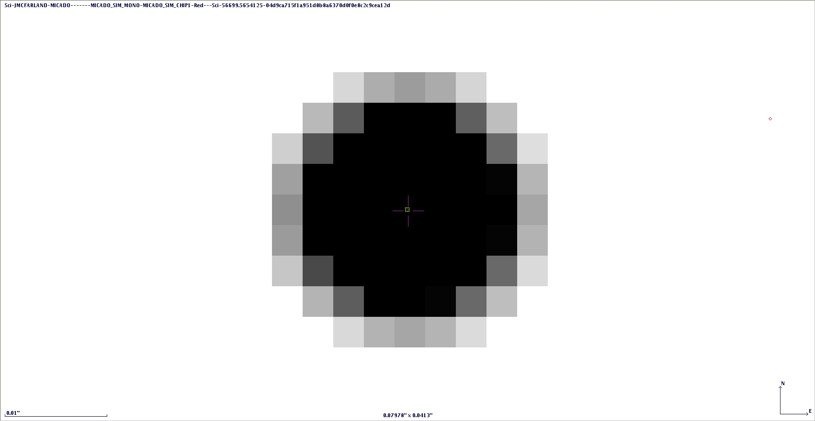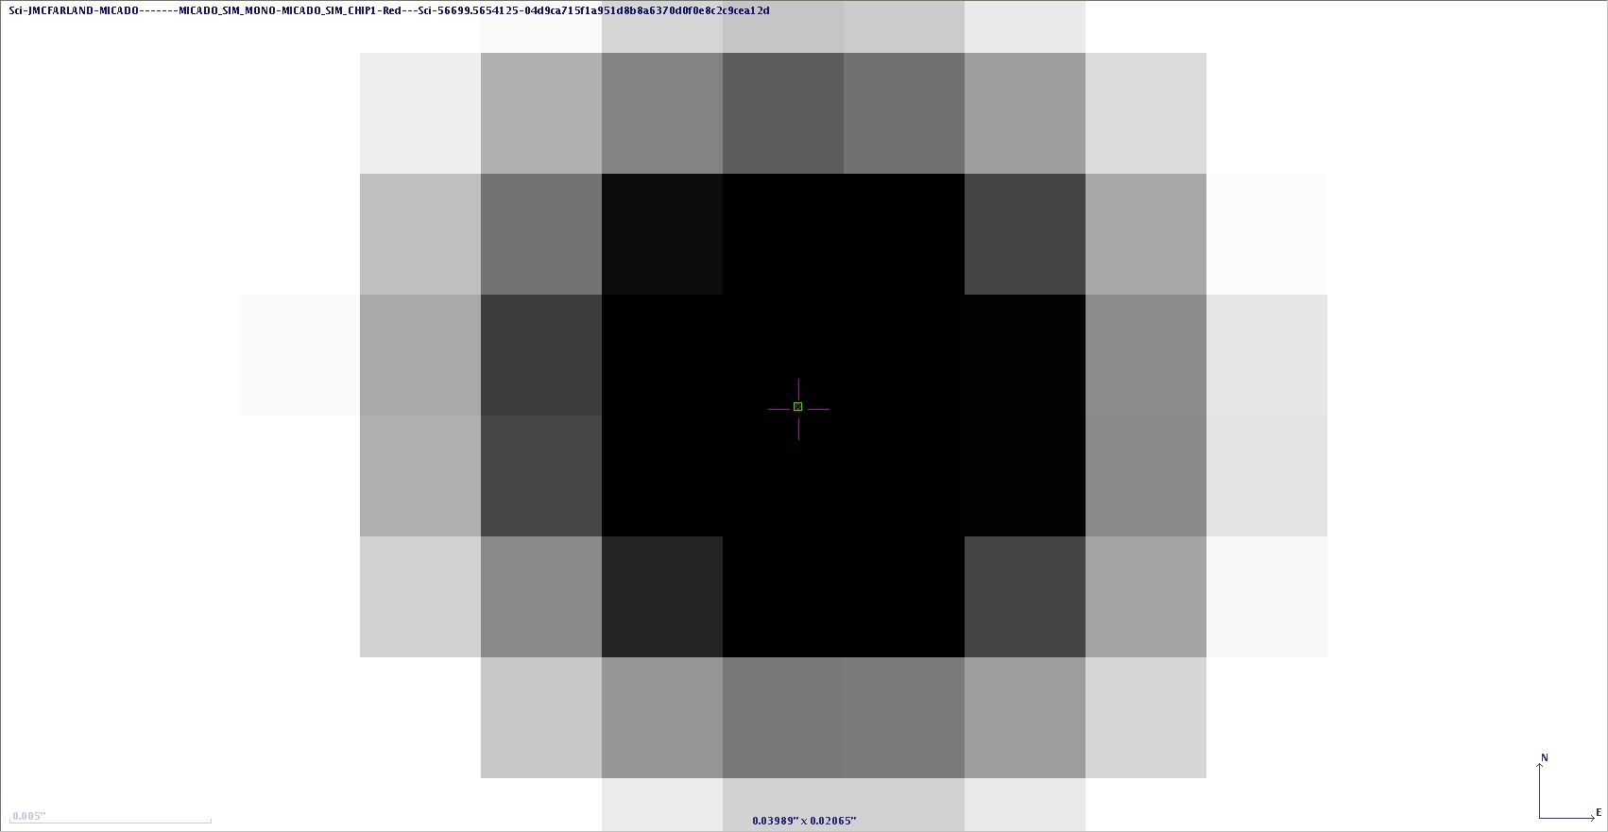
Fig1. Examples of centroid determinations in single exposure images for source 1 (left) and 2 (right). Shown are the central few pixels. The tiny green square indicates the measured centroid.
First we compared the distance measured from the barycentric method and Gaussian fitting. Figure 1 shows they typically deliver the same centroid to within 0.05 pixel with a few outliers for the single exposure images. We verified the standard deviation of the measured distances between source 1 and 2 in single exposure images is the same for both centroiding methods within 1%. This standard deviation is also the same within 1% if one takes only distances of exposures in which both centroiding methods for both sources agree to within 0.1 pixel. For this reason we restrict further analysis to barycentric centroiding measurements only.
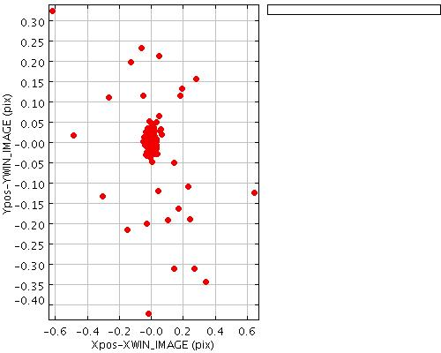
Fig 1. Difference in X and Y coordinate of centroid determined from a barycentric and Gaussian fit.
Exposures sampled every 3sec:—————
ID | source | exposures per stack | number of stacks | mean number of spurious detections per stack | mean X-distance (sigma) | mean Y-distance (sigma) | mean X_IMAGE (sigma) | mean Y_IMAGE (sigma) | mean FWHM_IMAGE (sigma) | mean FLUX_APER (sigma) | NPIX
 |  |  |  |  | [pixel] | [pixel] | [pixel] | [pixel] | [pixel] | [ADU]
1 | 5arcsec off-axis | 1 | 100 |  |  |  | 1459.947 (0.550) | 1459.689 (0.354) | 3.871 (0.093) | 1259574 (105752) | 162
2 | 10arcsec off-axis | 1 | 100 |  |  |  | 2638.259 (0.705) | 2638.231 (0.427) | 3.902 (0.163) | 949341 (101678) | 150
2-1 |  |  |  | 5.0 | 1178.312 (0.858) | 1178.541 (0.465)
1 | 5arcsec off-axis | 2 | 150 |  |  |  | 1459.905 (0.452) | 1459.733 (0.246) | 3.981 (0.188) | 1371170 (120839) | 200
2 | 10arcsec off-axis | 2 | 150 |  |  |  | 2638.297 (0.572) | 2638.260 (0.291) | 4.117 (0.312) | 1090340 (94302) | 216
2-1 |  |  |  | 2.5 | 1178.391 (0.702) | 1178.527 (0.344)
1 | 5arcsec off-axis | 4 | 75 |  |  |  | 1459.889 (0.326) | 1459.734 (0.175) | 3.992 (0.121) | 1453868 (79965) | 238
2 | 10arcsec off-axis | 4 | 75 |  |  |  | 2638.312 (0.465) | 2638.255 (0.202) | 4.134 (0.206) | 1156714 (63395) | 253
2-1 |  |  |  | 1.0 | 1178.422 (0.557) | 1178.521 (0.242)
1 | 5arcsec off-axis | 5 | 60 |  |  |  | 1459.875 (0.310) | 1459.717 (0.147) | 4.000 (0.123) | 1454038 (88757) | 239
2 | 10arcsec off-axis | 5 | 60 |  |  |  | 2638.314 (0.351) | 2638.236 (0.160) | 4.139 (0.197) | 1173078 (61769) | 270
2-1 |  |  |  | 0.7 | 1178.439 (0.472) | 1178.519 (0.188)
1 | 5arcsec off-axis | 10 | 30 |  |  |  | 1459.880 (0.232) | 1459.749 (0.079) | 3.965 (0.053) | 1471525 (65031) | 253
2 | 10arcsec off-axis | 10 | 30 |  |  |  | 2638.313 (0.257) | 2638.252 (0.106) | 4.102 (0.090) | 1181422 (60024) | 274
2-1 |  |  |  | 0.4 | 1178.433 (0.344) | 1178.502 (0.124)
1 | 5arcsec off-axis | 20 | 15 |  |  |  | 1459.889 (0.146) | 1459.743 (0.058) | 3.955 (0.028) | 1491539 (21963) | 275
2 | 10arcsec off-axis | 20 | 15 |  |  |  | 2638.308 (0.151) | 2638.255 (0.068) | 4.065 (0.056) | 1192187 (19476) | 284
2-1 |  |  |  | 0.0 | 1178.419 (0.205) | 1178.512 (0.084)
1 | 5arcsec off-axis | 25 | 12 |  |  |  | 1459.888 (0.156) | 1459.742 (0.057) | 3.948 (0.025) | 1491653 (20958) | 274
2 | 10arcsec off-axis | 25 | 12 |  |  |  | 2638.309 (0.129) | 2638.259 (0.056) | 4.063 (0.043) | 1192162 (19058) | 284
2-1 |  |  |  | 0.0 | 1178.421 (0.195) | 1178.517 (0.083)
1 | 5arcsec off-axis | 50 | 6 |  |  |  | 1459.890 (0.061) | 1459.743 (0.045) | 3.953 (0.023) | 1491299 (16119) | 276
2 | 10arcsec off-axis | 50 | 6 |  |  |  | 2638.305 (0.096) | 2638.256 (0.023) | 4.052 (0.026) | 1191872 (13888) | 284
2-1 |  |  |  | 0.0 | 1178.415 (0.130) | 1178.513 (0.044)
1 | 5arcsec off-axis | 100 | 3 |  |  |  | 1459.890 (0.053) | 1459.740 (0.028) | 3.949 (0.004) | 1490996 (4364) | 275
2 | 10arcsec off-axis | 100 | 3 |  |  |  | 2638.308 (0.086) | 2638.257 (0.022) | 4.050 (0.014) | 1192059 (3823) | 285
2-1 |  |  |  | 0.0 | 1178.417 (0.120) | 1178.517 (0.033)
Table 1. Statistics of extracted source parameters for set 1 (no ADC) for the sets of single exposures and coadds of 2, 4, 5, 10, 20, 25, 50 and 100 single exposures sampled every 3 seconds. Averages and standard deviations are listed for most parameters. Description of parameters is given in the text. The position measurements use SExtractor's default barycentric method.
Exposures sampled every 1sec:—————
ID | source | exposures per stack | number of stacks | mean number of spurious detections per stack | mean X-distance (sigma) | mean Y-distance (sigma) | mean X_IMAGE (sigma) | mean Y_IMAGE (sigma) | mean FWHM_IMAGE (sigma) | mean FLUX_APER (sigma) | NPIX
 |  |  |  |  | [pixel] | [pixel] | [pixel] | [pixel] | [pixel] | [ADU]
1 | 5arcsec off-axis | 1 | 100 |  |  |  | 1459.868 (0.524) | 1459.732 (0.406) | 3.884 (0.141) | 1254071 (119759) | 163
2 | 10arcsec off-axis | 1 | 100 |  |  |  | 2638.264 (0.757) | 2638.255 (0.420) | 3.930 (0.214) | 966125 (110074) | 158
2-1 |  |  |  | 5.1 | 1178.396 (0.893) | 1178.524 (0.475)
1 | 5arcsec off-axis | 2 | 50 |  |  |  | 1459.878 (0.417) | 1459.768 (0.275) | 3.987 (0.177) | 1366792 (128284) | 198
2 | 10arcsec off-axis | 2 | 50 |  |  |  | 2638.258 (0.656) | 2638.276 (0.363) | 4.086 (0.267) | 1095880 (88204) | 224
2-1 |  |  |  | 2.5 | 1178.380 (0.805) | 1178.507 (0.435)
1 | 5arcsec off-axis | 4 | 25 |  |  |  | 1459.863 (0.357) | 1459.769 (0.194) | 3.969 (0.097) | 1439098 (94023) | 231
2 | 10arcsec off-axis | 4 | 25 |  |  |  | 2638.240 (0.454) | 2638.251 (0.306) | 4.188 (0.239) | 1150882 (87792) | 250
2-1 |  |  |  | 1.3 | 1178.377 (0.567) | 1178.483 (0.273)
1 | 5arcsec off-axis | 5 | 20 |  |  |  | 1459.873 (0.362) | 1459.772 (0.193) | 4.023 (0.111) | 1435484 (109567) | 232
2 | 10arcsec off-axis | 5 | 20 |  |  |  | 2638.252 (0.529) | 2638.231 (0.150) | 4.152 (0.241) | 1163133 (65725) | 263
2-1 |  |  |  | 1.1 | 1178.379 (0.626) | 1178.459 (0.245)
1 | 5arcsec off-axis | 10 | 10 |  |  |  | 1459.876 (0.194) | 1459.752 (0.102) | 3.980 (0.073) | 1485786 (62257) | 259
2 | 10arcsec off-axis | 10 | 10 |  |  |  | 2638.218 (0.361) | 2638.290 (0.133) | 4.147 (0.085) | 1191883 (42554) | 278
2-1 |  |  |  | 0.4 | 1178.343 (0.385) | 1178.539 (0.200)
1 | 5arcsec off-axis | 20 | 5 |  |  |  | 1459.840 (0.168) | 1459.779 (0.060) | 3.951 (0.045) | 1446750 (113709) | 241
2 | 10arcsec off-axis | 20 | 5 |  |  |  | 2638.249 (0.130) | 2638.253 (0.051) | 4.083 (0.061) | 1196224 (22430) | 288
2-1 |  |  |  | 0.2 | 1178.409 (0.237) | 1178.474 (0.094)
1 | 5arcsec off-axis | 25 | 4 |  |  |  | 1459.834 (0.138) | 1459.766 (0.046) | 3.948 (0.013) | 1491999 (19009) | 274
2 | 10arcsec off-axis | 25 | 4 |  |  |  | 2638.250 (0.146) | 2638.251 (0.026) | 4.085 (0.029) | 1195797 (16665) | 288
2-1 |  |  |  | 0.0 | 1178.417 (0.162) | 1178.485 (0.054)
Table 2. Equivalent of Table 1. but now for exposures sampled every 1 second. Also, coadds of 50 and 100 single exposures have been omitted for statistical reasons (sample size too low).
In all images the sources have a FWHM ~ 4 pix (12 mas), i.e., close to the diffraction limited of 13 mas at 2.2 micron. The fact that it is slightly smaller could be due to the fact that the extraction does not identify the full wings of the profile as part of a single source. The second order moments X2 and Y2 indicate that the sources are elongated in the X direction compared to the Y direction. Any logic why this might be the case?.
The difference in peak values (60000 ADU for the source at 5arcsec from the AO star and 45000 ADU for the source at 10 arcsec) is expected due to anisoplanatism (e.g. Trippe et al.)
Figure 2 show that the scatter in the barycenters is anisotropic: it is a factor 2 higher in the X direction compared to the Y direction. Any logic why scatter is higher in the direction parallel to the wind?
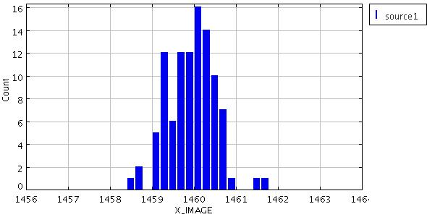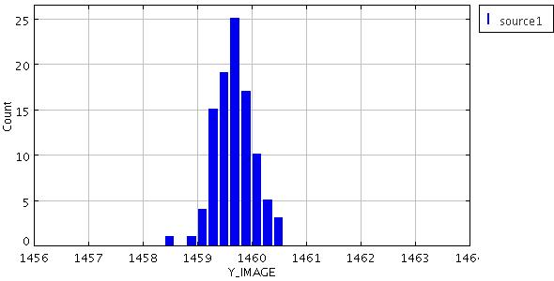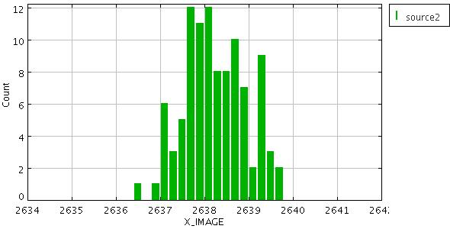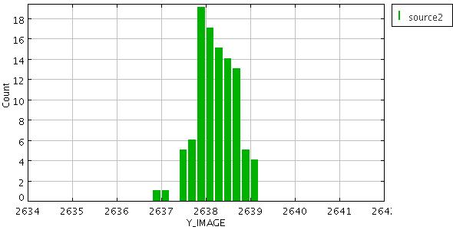
Fig 2. Extracted barycenters in X and Y for source 1 and 2 in the single exposure images.
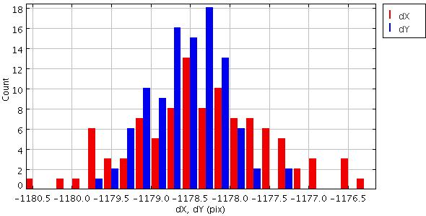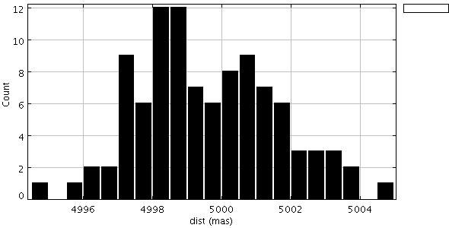
Fig3. Left: Pixel position difference delta(X_IMAGE) (red) and delta(Y_IMAGE) (blue) for source 1 and 2 in single exposures. Right: distance between source 1 and 2 in milliarcsec.
We want to determine if there is a systematic floor to the accuracy with which we can determine the distance between the two stars. In Fig 2. the red circles show that the standard deviation of the distance measurements across series of different coadds (consisting of 1, 2, 4, 5, 10 and 20 exposures) scales as 1/sqrt(#exposures). All coadd combinations of the 100 single exposures give a similarly accurate estimate of the distance with a standard deviation of ~200-250 microarcsec (shown as green diamonds). The exposure are statistically independent samplings of the distance and summing more and more is expected to decrease the standard deviation. In this fashion a standard deviation of 10 microarcsec is expected to be reached with (200/10)^2 * 100 = 40000 exposures.
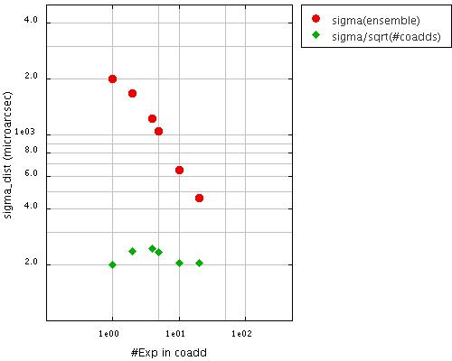
Figure 2: Standard deviation in microarcsec of distance measurements measured in single exposure images and in coadds of 2,4,5, 10 and 20 exposures. Both the standard deviation of the ensemble is shown (red circles) and the standard deviation of the mean of the ensemble (green diamonds).
Contributions to this error budget are coming from systematics in centroiding and differential tilt jitter
Source of systematic error | size (micro-arcsec) | comment
Centroiding | unknown
Differential tilt jitter | 54 | predicted
- | 200 | observed
The prediction for the differential tilt jitter is done by scaling the description in Trippe et al. to the specifications used in our simulations.
The difference between the two error budgets is that differential tilt jitter is expected to broaden the PSF on timescales longer than the wind crossing time (~3sec) while systematic centroiding errors do not cause an intrinsic broadening. For a coadd of 100 exposures which are sampled over a period of 100 or 300seconds the FWHM = 3.904 pix for source 1 and FWHM = 4.05 pix for source 2. For the single exposures it is FWHM = 3.880 and FWHM = 3.905 pix. The <0.15 pix difference is much smaller than the observed scatter in the single exposures of standard deviation of ~0.6-0.7 pix in X and ~0.3-0.4 pix in Y. Especially since FWHM ~ 2 sigma for typical PSFs. The most likely explanation is that systematic errors in the centroiding dominate.
Given that the single exposures are 0.001s snapshots the 40000 exposures would correspond to 4s exposure times.
If the 3s samplings of 0.001s snapshots are representative of 3sec exposures this would amount to 3hrs of exposure time.

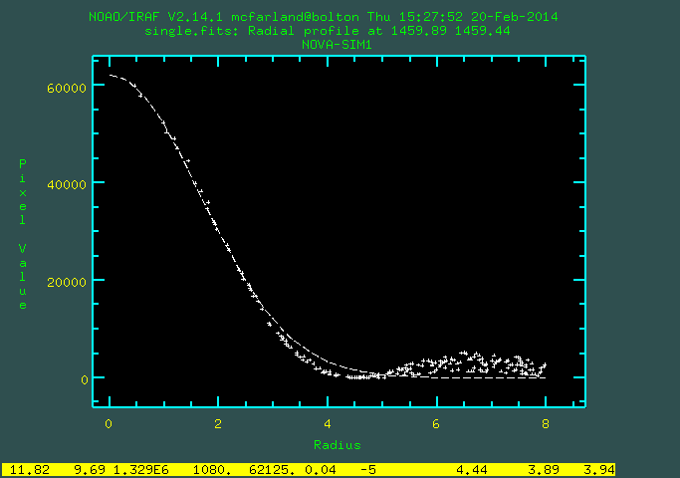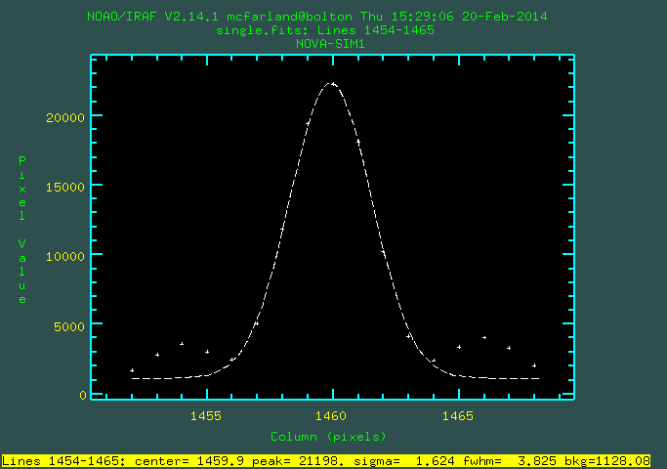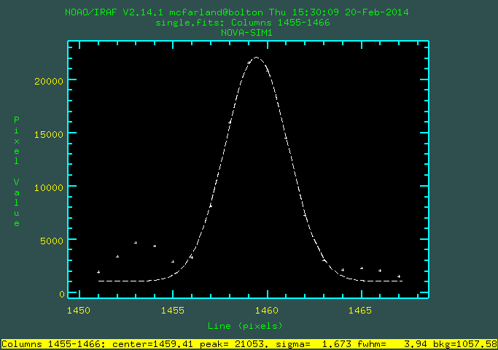
Figures ?-?: Radial and profile plots (IRAF imexamine) of a single simulated exposure (0.001 second image)
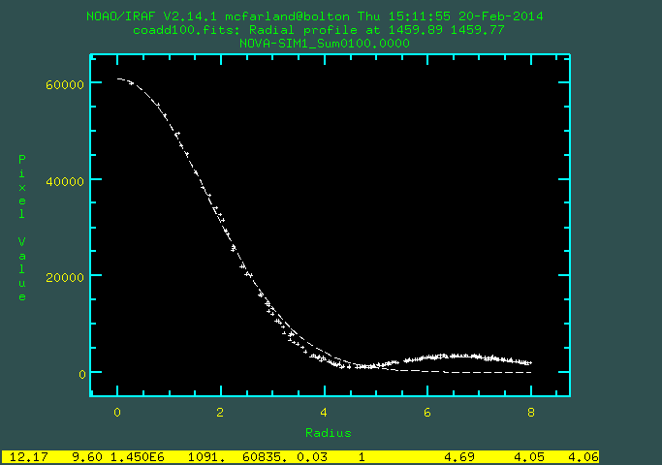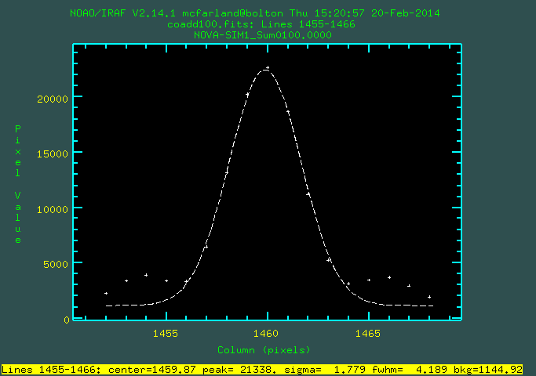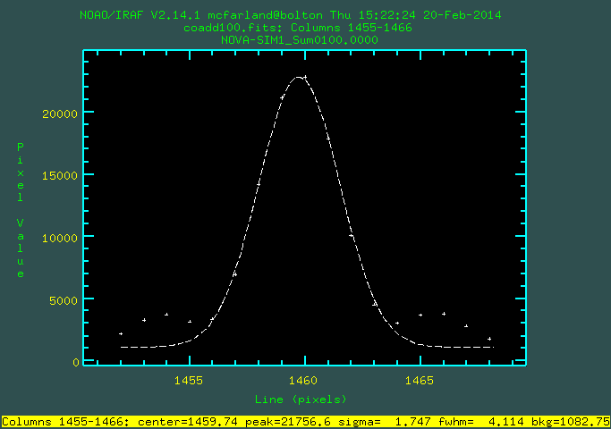
Figures ?-?: Radial and profile plots (IRAF imexamine) of a stack of 100 single simulated exposures

perfect pupil place ADC simulations
- for all tables below
  - source ID 1 is a source 5 arcsec from AO/guide star and source ID 2 is a source 10 arcsec from AO/guide star
  - atmospheric sampling is 1 second
ZD = 0 deg with ADC
source ID | exposures per stack | number of stacks | mean number of spurious detections per stack | mean X-distance (sigma) | mean XWIN-distance (sigma) | mean Y-distance (sigma) | mean YWIN-distance (sigma) | mean X_IMAGE (sigma) | mean XWIN_IMAGE (sigma) | mean Y_IMAGE (sigma) | mean YWIN_IMAGE (sigma) | mean FWHM_IMAGE (sigma) | mean FLUX_APER (sigma) | NPIX
 |  |  |  | [pixel] | [pixel] | [pixel] | [pixel] | [pixel] | [pixel] | [pixel] | [pixel] | [pixel] | [ADU]
1 | 1 | 100 |  |  |  |  |  | 2049.120 (0.535) | 2049.122 (0.526) | 2049.013 (0.365) | 2048.993 (0.398) | 3.940 (0.254) | 1325284 (110330) | 221
2 | 1 | 100 |  |  |  |  |  | 3715.675 (0.773) | 3715.675 (0.771) | 2049.028 (0.406) | 2048.995 (0.413) | 3.974 (0.309) | 1025233 (93542) | 208
2-1 |  |  | 2.7 | 1666.555 (0.900) | 1666.553 (0.919) | 0.015 (0.450) | 0.001 (0.470)
1 | 2 | 50 |  |  |  |  |  | 2049.125 (0.469) | 2049.121 (0.404) | 2049.034 (0.250) | 2048.994 (0.271) | 4.027 (0.246) | 1415423 (89167) | 256
2 | 2 | 50 |  |  |  |  |  | 3715.652 (0.631) | 3715.668 (0.635) | 2049.012 (0.370) | 2048.996 (0.312) | 4.070 (0.244) | 1117526 (76906) | 259
2-1 |  |  | 1.1 | 1666.526 (0.778) | 1666.547 (0.769) | -0.022 (0.400) | 0.002 (0.345)
1 | 4 | 25 |  |  |  |  |  | 2049.094 (0.333) | 2049.122 (0.300) | 2049.047 (0.187) | 2048.994 (0.197) | 3.990 (0.094) | 1463112 (62426) | 283
2 | 4 | 25 |  |  |  |  |  | 3715.696 (0.509) | 3715.662 (0.472) | 2048.984 (0.304) | 2048.997 (0.251) | 4.174 (0.251) | 1170023 (48370) | 290
2-1 |  |  | 0.2 | 1666.602 (0.615) | 1666.540 (0.563) | -0.063 (0.282) | 0.002 (0.216)
1 | 5 | 20 |  |  |  |  |  | 2049.093 (0.313) | 2049.123 (0.268) | 2049.044 (0.172) | 2048.992 (0.203) | 3.970 (0.098) | 1465182 (68592) | 282
2 | 5 | 20 |  |  |  |  |  | 3715.650 (0.526) | 3715.664 (0.452) | 2048.991 (0.131) | 2048.998 (0.141) | 4.128 (0.167) | 1172167 (54107) | 294
2-1 |  |  | 0.2 | 1666.557 (0.599) | 1666.540 (0.507) | -0.053 (0.175) | 0.006 (0.177)
1 | 10 | 10 |  |  |  |  |  | 2049.086 (0.185) | 2049.124 (0.176) | 2049.029 (0.101) | 2048.995 (0.079) | 3.941 (0.061) | 1472070 (49882) | 290
2 | 10 | 10 |  |  |  |  |  | 3715.658 (0.383) | 3715.659 (0.294) | 2048.992 (0.097) | 2048.999 (0.097) | 4.146 (0.054) | 1180005 (38939) | 301
2-1 |  |  | 0.0 | 1666.572 (0.442) | 1666.536 (0.364) | -0.036 (0.121) | 0.004 (0.096)
1 | 20 | 5 |  |  |  |  |  | 2049.085 (0.173) | 2049.124 (0.145) | 2049.028 (0.070) | 2048.995 (0.044) | 3.929 (0.036) | 1471528 (36941) | 290
2 | 20 | 5 |  |  |  |  |  | 3715.653 (0.129) | 3715.666 (0.164) | 2048.990 (0.047) | 2049.000 (0.040) | 4.090 (0.060) | 1179025 (26043) | 302
2-1 |  |  | 0.0 | 1666.567 (0.236) | 1666.542 (0.195) | -0.038 (0.100) | 0.005 (0.049)
ZD = 35 deg with ADC
source ID | exposures per stack | number of stacks | mean number of spurious detections per stack | mean X-distance (sigma) | mean XWIN-distance (sigma) | mean Y-distance (sigma) | mean YWIN-distance (sigma) | mean X_IMAGE (sigma) | mean XWIN_IMAGE (sigma) | mean Y_IMAGE (sigma) | mean YWIN_IMAGE (sigma) | mean FWHM_IMAGE (sigma) | mean FLUX_APER (sigma) | NPIX
 |  |  |  | [pixel] | [pixel] | [pixel] | [pixel] | [pixel] | [pixel] | [pixel] | [pixel] | [pixel] | [ADU]
1 | 1 | 100 |  |  |  |  |  | 2049.155 (0.519) | 2049.137 (0.526) | 2037.737 (0.379) | 2037.731 (0.398) | 3.925 (0.232) | 1320743 (108038) | 214
2 | 1 | 100 |  |  |  |  |  | 3715.693 (0.769) | 3715.690 (0.771) | 2037.079 (0.411) | 2037.044 (0.413) | 3.993 (0.317) | 1031447 (95043) | 210
2-1 |  |  | 2.8 | 1666.537 (0.897) | 1666.553 (0.919) | -0.658 (0.469) | -0.687 (0.470)
1 | 2 | 50 |  |  |  |  |  | 2049.145 (0.441) | 2049.137 (0.404) | 2037.762 (0.238) | 2037.732 (0.271) | 4.010 (0.244) | 1425150 (86403) | 256
2 | 2 | 50 |  |  |  |  |  | 3715.678 (0.628) | 3715.684 (0.634) | 2037.061 (0.365) | 2037.045 (0.311) | 4.065 (0.245) | 1123847 (76615) | 259
2-1 |  |  | 1.1 | 1666.533 (0.780) | 1666.547 (0.769) | -0.701 (0.401) | -0.687 (0.344)
1 | 4 | 25 |  |  |  |  |  | 2049.117 (0.318) | 2049.137 (0.300) | 2037.790 (0.178) | 2037.733 (0.197) | 3.982 (0.092) | 1473584 (54922) | 281
2 | 4 | 25 |  |  |  |  |  | 3715.704 (0.503) | 3715.677 (0.472) | 2037.027 (0.301) | 2037.046 (0.251) | 4.170 (0.244) | 1177129 (48664) | 291
2-1 |  |  | 0.3 | 1666.587 (0.603) | 1666.539 (0.563) | -0.762 (0.275) | -0.687 (0.216)
1 | 5 | 20 |  |  |  |  |  | 2049.116 (0.313) | 2049.139 (0.268) | 2037.773 (0.175) | 2037.730 (0.203) | 3.973 (0.094) | 1478942 (62801) | 285
2 | 5 | 20 |  |  |  |  |  | 3715.665 (0.526) | 3715.679 (0.452) | 2037.043 (0.132) | 2037.047 (0.141) | 4.126 (0.163) | 1180548 (53634) | 295
2-1 |  |  | 0.1 | 1666.548 (0.600) | 1666.540 (0.507) | -0.730 (0.175) | -0.683 (0.177)
1 | 10 | 10 |  |  |  |  |  | 2049.101 (0.187) | 2049.139 (0.176) | 2037.767 (0.102) | 2037.733 (0.079) | 3.933 (0.068) | 1490360 (52927) | 289
2 | 10 | 10 |  |  |  |  |  | 3715.670 (0.383) | 3715.674 (0.294) | 2037.040 (0.097) | 2037.049 (0.097) | 4.145 (0.056) | 1194461 (41288) | 303
2-1 |  |  | 0.0 | 1666.569 (0.441) | 1666.535 (0.364) | -0.727 (0.124) | -0.685 (0.097)
1 | 20 | 5 |  |  |  |  |  | 2049.103 (0.176) | 2049.139 (0.145) | 2037.769 (0.072) | 2037.734 (0.044) | 3.928 (0.059) | 1489307 (36116) | 291
2 | 20 | 5 |  |  |  |  |  | 3715.670 (0.131) | 3715.681 (0.164) | 2037.043 (0.046) | 2037.049 (0.040) | 4.087 (0.053) | 1193503 (24630) | 305
2-1 |  |  | 0.0 | 1666.567 (0.243) | 1666.542 (0.195) | -0.726 (0.100) | -0.685 (0.049)
ZD = 30 deg with ADC
source ID | exposures per stack | number of stacks | mean number of spurious detections per stack | mean X-distance (sigma) | mean XWIN-distance (sigma) | mean Y-distance (sigma) | mean YWIN-distance (sigma) | mean X_IMAGE (sigma) | mean XWIN_IMAGE (sigma) | mean Y_IMAGE (sigma) | mean YWIN_IMAGE (sigma) | mean FWHM_IMAGE (sigma) | mean FLUX_APER (sigma) | NPIX
 |  |  |  | [pixel] | [pixel] | [pixel] | [pixel] | [pixel] | [pixel] | [pixel] | [pixel] | [pixel] | [ADU]
1 | 1 | 100 |  |  |  |  |  | 2049.141 (0.521) | 2049.133 (0.526) | 2039.717 (0.371) | 2039.705 (0.398) | 3.931 (0.241) | 1323013 (107868) | 216
2 | 1 | 100 |  |  |  |  |  | 3715.681 (0.776) | 3715.685 (0.771) | 2040.013 (0.410) | 2039.972 (0.413) | 3.988 (0.325) | 1030178 (94907) | 209
2-1 |  |  | 2.8 | 1666.540 (0.895) | 1666.553 (0.920) | 0.296 (0.464) | 0.267 (0.470)
1 | 2 | 50 |  |  |  |  |  | 2049.145 (0.440) | 2049.132 (0.404) | 2039.740 (0.236) | 2039.706 (0.270) | 4.014 (0.244) | 1425881 (86213) | 256
2 | 2 | 50 |  |  |  |  |  | 3715.672 (0.660) | 3715.679 (0.635) | 2039.976 (0.372) | 2039.973 (0.312) | 4.099 (0.298) | 1127743 (73798) | 260
2-1 |  |  | 1.1 | 1666.527 (0.800) | 1666.547 (0.770) | 0.236 (0.416) | 0.267 (0.344)
1 | 4 | 25 |  |  |  |  |  | 2049.103 (0.332) | 2049.132 (0.300) | 2039.759 (0.184) | 2039.707 (0.197) | 3.986 (0.093) | 1477319 (55055) | 283
2 | 4 | 25 |  |  |  |  |  | 3715.692 (0.494) | 3715.672 (0.472) | 2039.967 (0.279) | 2039.974 (0.249) | 4.160 (0.230) | 1178620 (41568) | 291
2-1 |  |  | 0.2 | 1666.589 (0.614) | 1666.540 (0.564) | 0.208 (0.267) | 0.267 (0.216)
1 | 5 | 20 |  |  |  |  |  | 2049.111 (0.314) | 2049.134 (0.268) | 2039.747 (0.175) | 2039.704 (0.203) | 3.975 (0.098) | 1480382 (61721) | 285
2 | 5 | 20 |  |  |  |  |  | 3715.661 (0.526) | 3715.674 (0.452) | 2039.971 (0.132) | 2039.974 (0.141) | 4.128 (0.165) | 1182443 (51613) | 295
2-1 |  |  | 0.1 | 1666.550 (0.600) | 1666.540 (0.507) | 0.223 (0.177) | 0.270 (0.177)
1 | 10 | 10 |  |  |  |  |  | 2049.097 (0.188) | 2049.134 (0.176) | 2039.741 (0.103) | 2039.707 (0.079) | 3.934 (0.067) | 1493535 (53225) | 290
2 | 10 | 10 |  |  |  |  |  | 3715.664 (0.383) | 3715.670 (0.294) | 2039.970 (0.098) | 2039.976 (0.097) | 4.141 (0.057) | 1197191 (41426) | 303
2-1 |  |  | 0.0 | 1666.567 (0.442) | 1666.535 (0.363) | 0.229 (0.126) | 0.269 (0.096)
1 | 20 | 5 |  |  |  |  |  | 2049.098 (0.174) | 2049.134 (0.145) | 2039.743 (0.070) | 2039.708 (0.044) | 3.927 (0.057) | 1492422 (36189) | 290
2 | 20 | 5 |  |  |  |  |  | 3715.664 (0.128) | 3715.677 (0.164) | 2039.968 (0.045) | 2039.976 (0.040) | 4.093 (0.068) | 1196253 (24687) | 304
2-1 |  |  | 0.0 | 1666.566 (0.241) | 1666.542 (0.195) | 0.225 (0.099) | 0.269 (0.049)
ZD = 60 deg with ADC
source ID | exposures per stack | number of stacks | mean number of spurious detections per stack | mean X-distance (sigma) | mean XWIN-distance (sigma) | mean Y-distance (sigma) | mean YWIN-distance (sigma) | mean X_IMAGE (sigma) | mean XWIN_IMAGE (sigma) | mean Y_IMAGE (sigma) | mean YWIN_IMAGE (sigma) | mean FWHM_IMAGE (sigma) | mean FLUX_APER (sigma) | NPIX
 |  |  |  | [pixel] | [pixel] | [pixel] | [pixel] | [pixel] | [pixel] | [pixel] | [pixel] | [pixel] | [ADU]
1 | 1 | 100 |  |  |  |  |  | 2049.155 (0.540) | 2049.147 (0.526) | 2021.238 (0.370) | 2021.233 (0.398) | 3.942 (0.288) | 1324296 (109351) | 219
2 | 1 | 100 |  |  |  |  |  | 3715.695 (0.765) | 3715.699 (0.771) | 2021.299 (0.415) | 2021.271 (0.414) | 3.960 (0.286) | 1022258 (96416) | 207
2-1 |  |  | 2.7 | 1666.540 (0.899) | 1666.551 (0.920) | 0.062 (0.453) | 0.039 (0.470)
1 | 2 | 50 |  |  |  |  |  | 2049.153 (0.438) | 2049.147 (0.404) | 2021.289 (0.246) | 2021.233 (0.271) | 4.024 (0.238) | 1427484 (82806) | 259
2 | 2 | 50 |  |  |  |  |  | 3715.682 (0.628) | 3715.693 (0.635) | 2021.289 (0.369) | 2021.273 (0.311) | 4.066 (0.242) | 1122864 (78126) | 260
2-1 |  |  | 1.1 | 1666.528 (0.773) | 1666.545 (0.769) | 0.001 (0.416) | 0.040 (0.344)
1 | 4 | 25 |  |  |  |  |  | 2049.122 (0.332) | 2049.148 (0.300) | 2021.285 (0.181) | 2021.234 (0.197) | 3.986 (0.098) | 1474357 (64167) | 281
2 | 4 | 25 |  |  |  |  |  | 3715.704 (0.498) | 3715.686 (0.472) | 2021.234 (0.288) | 2021.273 (0.251) | 4.129 (0.192) | 1176266 (54692) | 290
2-1 |  |  | 0.3 | 1666.582 (0.599) | 1666.538 (0.563) | -0.051 (0.275) | 0.039 (0.216)
1 | 5 | 20 |  |  |  |  |  | 2049.134 (0.318) | 2049.149 (0.268) | 2021.261 (0.164) | 2021.231 (0.203) | 3.960 (0.096) | 1472308 (65987) | 278
2 | 5 | 20 |  |  |  |  |  | 3715.670 (0.525) | 3715.688 (0.452) | 2021.263 (0.127) | 2021.275 (0.141) | 4.114 (0.179) | 1181814 (51974) | 295
2-1 |  |  | 0.2 | 1666.536 (0.594) | 1666.539 (0.507) | 0.002 (0.172) | 0.044 (0.177)
1 | 10 | 10 |  |  |  |  |  | 2049.111 (0.187) | 2049.149 (0.176) | 2021.267 (0.106) | 2021.235 (0.079) | 3.930 (0.056) | 1487282 (50494) | 289
2 | 10 | 10 |  |  |  |  |  | 3715.681 (0.382) | 3715.683 (0.294) | 2021.270 (0.096) | 2021.277 (0.097) | 4.122 (0.063) | 1192211 (39429) | 302
2-1 |  |  | 0.0 | 1666.570 (0.441) | 1666.534 (0.363) | 0.003 (0.128) | 0.042 (0.097)
1 | 20 | 5 |  |  |  |  |  | 2049.113 (0.176) | 2049.149 (0.145) | 2021.264 (0.072) | 2021.235 (0.044) | 3.920 (0.037) | 1486682 (39624) | 291
2 | 20 | 5 |  |  |  |  |  | 3715.680 (0.129) | 3715.690 (0.164) | 2021.271 (0.049) | 2021.277 (0.040) | 4.073 (0.058) | 1191547 (28934) | 303
2-1 |  |  | 0.0 | 1666.567 (0.241) | 1666.541 (0.195) | 0.007 (0.103) | 0.042 (0.050)
ZD = 0 deg without ADC
source ID | exposures per stack | number of stacks | mean number of spurious detections per stack | mean X-distance (sigma) | mean XWIN-distance (sigma) | mean Y-distance (sigma) | mean YWIN-distance (sigma) | mean X_IMAGE (sigma) | mean XWIN_IMAGE (sigma) | mean Y_IMAGE (sigma) | mean YWIN_IMAGE (sigma) | mean FWHM_IMAGE (sigma) | mean FLUX_APER (sigma) | NPIX
 |  |  |  | [pixel] | [pixel] | [pixel] | [pixel] | [pixel] | [pixel] | [pixel] | [pixel] | [pixel] | [ADU]
1 | 1 | 100 |  |  |  |  |  | 1459.868 (0.524) | 1459.866 (0.526) | 1459.732 (0.406) | 1459.736 (0.400) | 3.884 (0.141) | 1254071 (119759) | 163
2 | 1 | 100 |  |  |  |  |  | 2638.264 (0.757) | 2638.265 (0.772) | 2638.255 (0.420) | 2638.249 (0.415) | 3.930 (0.214) | 966125 (110074) | 158
2-1 |  |  | 5.1 | 1178.396 (0.893) | 1178.399 (0.921) | 1178.524 (0.475) | 1178.513 (0.472)
1 | 2 | 50 |  |  |  |  |  | 1459.878 (0.417) | 1459.866 (0.404) | 1459.768 (0.275) | 1459.737 (0.272) | 3.987 (0.177) | 1366792 (128284) | 198
2 | 2 | 50 |  |  |  |  |  | 2638.258 (0.656) | 2638.258 (0.637) | 2638.276 (0.363) | 2638.252 (0.312) | 4.086 (0.267) | 1095880 (88204) | 224
2-1 |  |  | 2.5 | 1178.380 (0.805) | 1178.392 (0.772) | 1178.507 (0.435) | 1178.515 (0.346)
1 | 4 | 25 |  |  |  |  |  | 1459.863 (0.357) | 1459.867 (0.301) | 1459.769 (0.194) | 1459.738 (0.198) | 3.969 (0.097) | 1439098 (94023) | 231
2 | 4 | 25 |  |  |  |  |  | 2638.240 (0.454) | 2638.251 (0.472) | 2638.251 (0.306) | 2638.253 (0.252) | 4.188 (0.239) | 1150882 (87792) | 250
2-1 |  |  | 1.3 | 1178.377 (0.567) | 1178.384 (0.563) | 1178.483 (0.273) | 1178.516 (0.217)
1 | 5 | 20 |  |  |  |  |  | 1459.873 (0.362) | 1459.869 (0.268) | 1459.772 (0.193) | 1459.735 (0.204) | 4.023 (0.111) | 1435484 (109567) | 232
2 | 5 | 20 |  |  |  |  |  | 2638.252 (0.529) | 2638.253 (0.452) | 2638.231 (0.150) | 2638.252 (0.144) | 4.152 (0.241) | 1163133 (65725) | 263
2-1 |  |  | 1.1 | 1178.379 (0.626) | 1178.385 (0.508) | 1178.459 (0.245) | 1178.517 (0.180)
1 | 10 | 10 |  |  |  |  |  | 1459.876 (0.194) | 1459.869 (0.177) | 1459.752 (0.102) | 1459.739 (0.079) | 3.980 (0.073) | 1485786 (62257) | 259
2 | 10 | 10 |  |  |  |  |  | 2638.218 (0.361) | 2638.248 (0.294) | 2638.290 (0.133) | 2638.255 (0.097) | 4.147 (0.085) | 1191883 (42554) | 278
2-1 |  |  | 0.4 | 1178.343 (0.385) | 1178.379 (0.364) | 1178.539 (0.200) | 1178.516 (0.096)
1 | 20 | 5 |  |  |  |  |  | 1459.840 (0.168) | 1459.869 (0.145) | 1459.779 (0.060) | 1459.740 (0.044) | 3.951 (0.045) | 1446750 (113709) | 241
2 | 20 | 5 |  |  |  |  |  | 2638.249 (0.130) | 2638.256 (0.165) | 2638.253 (0.051) | 2638.255 (0.040) | 4.083 (0.061) | 1196224 (22430) | 288
2-1 |  |  | 0.2 | 1178.409 (0.237) | 1178.387 (0.195) | 1178.474 (0.094) | 1178.516 (0.049)
- summary tables
ZD = 0,30,35,60 deg with ADC:
source ID | exposures per stack | number of stacks | mean number of spurious detections per stack | mean X-distance (sigma) | mean XWIN-distance (sigma) | mean Y-distance (sigma) | mean YWIN-distance (sigma) | mean X_IMAGE (sigma) | mean XWIN_IMAGE (sigma) | mean Y_IMAGE (sigma) | mean YWIN_IMAGE (sigma) | mean FWHM_IMAGE (sigma) | mean FLUX_APER (sigma) | NPIX
 |  |  |  | [pixel] | [pixel] | [pixel] | [pixel] | [pixel] | [pixel] | [pixel] | [pixel] | [pixel] | [ADU]
1 | 10 | 10 |  |  |  |  |  | 2049.086 (0.185) | 2049.124 (0.176) | 2049.029 (0.101) | 2048.995 (0.079) | 3.941 (0.061) | 1472070 (49882) | 290
2 | 10 | 10 |  |  |  |  |  | 3715.658 (0.383) | 3715.659 (0.294) | 2048.992 (0.097) | 2048.999 (0.097) | 4.146 (0.054) | 1180005 (38939) | 301
2-1 |  |  | 0.0 | 1666.572 (0.442) | 1666.536 (0.364) | -0.036 (0.121) | 0.004 (0.096)
1 | 10 | 10 |  |  |  |  |  | 2049.101 (0.187) | 2049.139 (0.176) | 2037.767 (0.102) | 2037.733 (0.079) | 3.933 (0.068) | 1490360 (52927) | 289
2 | 10 | 10 |  |  |  |  |  | 3715.670 (0.383) | 3715.674 (0.294) | 2037.040 (0.097) | 2037.049 (0.097) | 4.145 (0.056) | 1194461 (41288) | 303
2-1 |  |  | 0.0 | 1666.569 (0.441) | 1666.535 (0.364) | -0.727 (0.124) | -0.685 (0.097)
1 | 10 | 10 |  |  |  |  |  | 2049.097 (0.188) | 2049.134 (0.176) | 2039.741 (0.103) | 2039.707 (0.079) | 3.934 (0.067) | 1493535 (53225) | 290
2 | 10 | 10 |  |  |  |  |  | 3715.664 (0.383) | 3715.670 (0.294) | 2039.970 (0.098) | 2039.976 (0.097) | 4.141 (0.057) | 1197191 (41426) | 303
2-1 |  |  | 0.0 | 1666.567 (0.442) | 1666.535 (0.363) | 0.229 (0.126) | 0.269 (0.096)
1 | 10 | 10 |  |  |  |  |  | 2049.111 (0.187) | 2049.149 (0.176) | 2021.267 (0.106) | 2021.235 (0.079) | 3.930 (0.056) | 1487282 (50494) | 289
2 | 10 | 10 |  |  |  |  |  | 3715.681 (0.382) | 3715.683 (0.294) | 2021.270 (0.096) | 2021.277 (0.097) | 4.122 (0.063) | 1192211 (39429) | 302
2-1 |  |  | 0.0 | 1666.570 (0.441) | 1666.534 (0.363) | 0.003 (0.128) | 0.042 (0.097)
to be compared with:
ZD = 0 deg without ADC:
source ID | exposures per stack | number of stacks | mean number of spurious detections per stack | mean X-distance (sigma) | mean XWIN-distance (sigma) | mean Y-distance (sigma) | mean YWIN-distance (sigma) | mean X_IMAGE (sigma) | mean XWIN_IMAGE (sigma) | mean Y_IMAGE (sigma) | mean YWIN_IMAGE (sigma) | mean FWHM_IMAGE (sigma) | mean FLUX_APER (sigma) | NPIX
 |  |  |  | [pixel] | [pixel] | [pixel] | [pixel] | [pixel] | [pixel] | [pixel] | [pixel] | [pixel] | [ADU]
1 | 10 | 10 |  |  |  |  |  | 1459.876 (0.194) | 1459.869 (0.177) | 1459.752 (0.102) | 1459.739 (0.079) | 3.980 (0.073) | 1485786 (62257) | 259
2 | 10 | 10 |  |  |  |  |  | 2638.218 (0.361) | 2638.248 (0.294) | 2638.290 (0.133) | 2638.255 (0.097) | 4.147 (0.085) | 1191883 (42554) | 278
2-1 |  |  | 0.4 | 1178.343 (0.385) | 1178.379 (0.364) | 1178.539 (0.200) | 1178.516 (0.096)

Reference frame construction **editor GVK**
- what makes most sense to determine astrometric error budget for ADC:
  - reference frame = first image: to quantify astrometric rms
  - reference frame = derived from ensemble of images: to quantify sqrt(n) effects
  - reference frame = true positions?: best for simulated images to assess both of the above.

Relative astrometry **editor GVK**
We then perform relative astrometric analysis.For each dataset we quantify the relative astrometric quality: rms(position) within a set of dithers using the following approaches:
- residuals: pos(im)-pos(ref_im)
- do usual approach? (e.g., Kuijken/Rich papers)
- Existing astrometric pipeline in Astro-WISE. It uses sextractor for source extraction and LDAC and SCAMP for astrometric calibration. Configuration is polynomial mapping. Needs fine-tuning to get beyond global astrometry of rms(0.03)/fwhm(0.7)=4e-2
- GEMS method
- astrom solution based on ensemble of (dithered) exposures (use current astrometric pipeline (SCAMP and/or LDAC))
  - output: x,y,ra,dec of stars + parametric fit to systematic distorsions over FoV.
  - Quantify distorsions: parameterize or look-up table?

Discussion
- Compare MICADO astrometric results to other (MAD, GemS) results in units PSF/pixelscale?

Conclusions
- outlook on future:
  - source detection on stacked data (light-curve software relevant here?) = master astrometric reference frame
  - can we exploit non-destructive read-outs? (contact Gert Finger)
  - better PSF modelling (starfinder, daophot, inspiration in Anderson + King-2000PASP112,1360 and KiDS PSF anisotropy/homogenization measurements?)
  - possibly astrometric calibration of GemS/MAD data (to get handle on MCAO case)

References and handy-links
- Dropbox astrometry documents
- Astro-WISE astrometry report
- Gijs' MICADO spreadsheets
- MICADO code repository at OmegaCEN

